Terraform Task

1). Install Terraform on your PC
Search for terraform for windows and download the executable
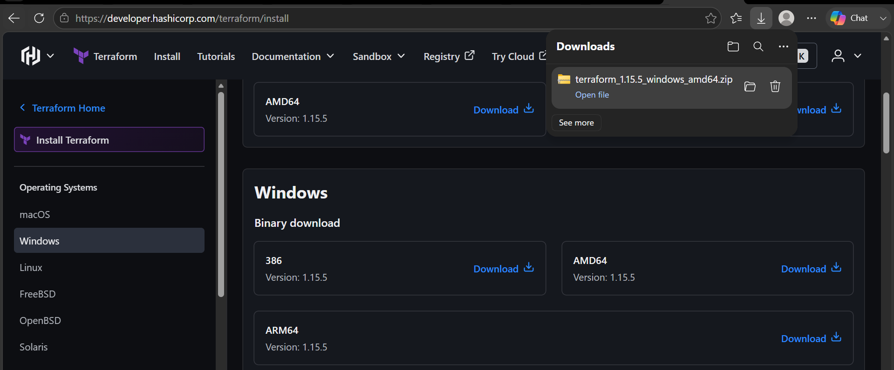

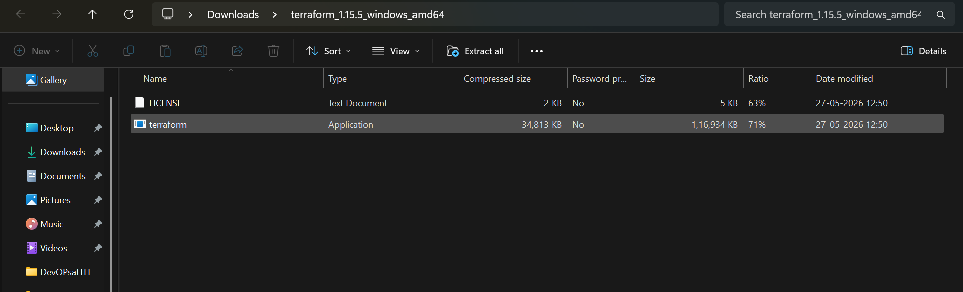

Now add the terraform path in terraform system variables
Search for environment variables in search bar
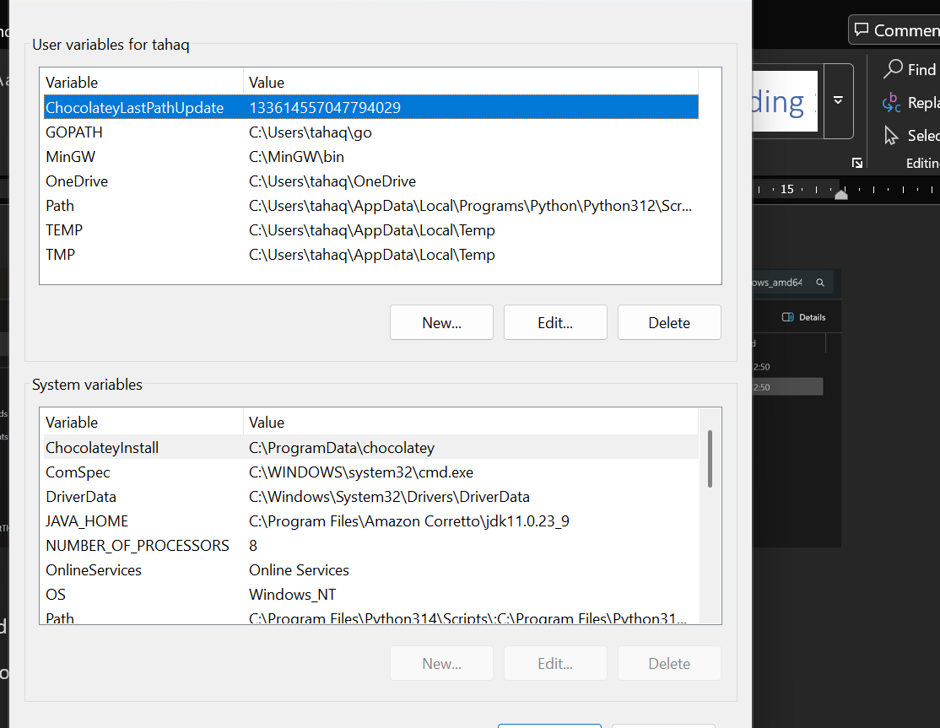

Edit the path variable
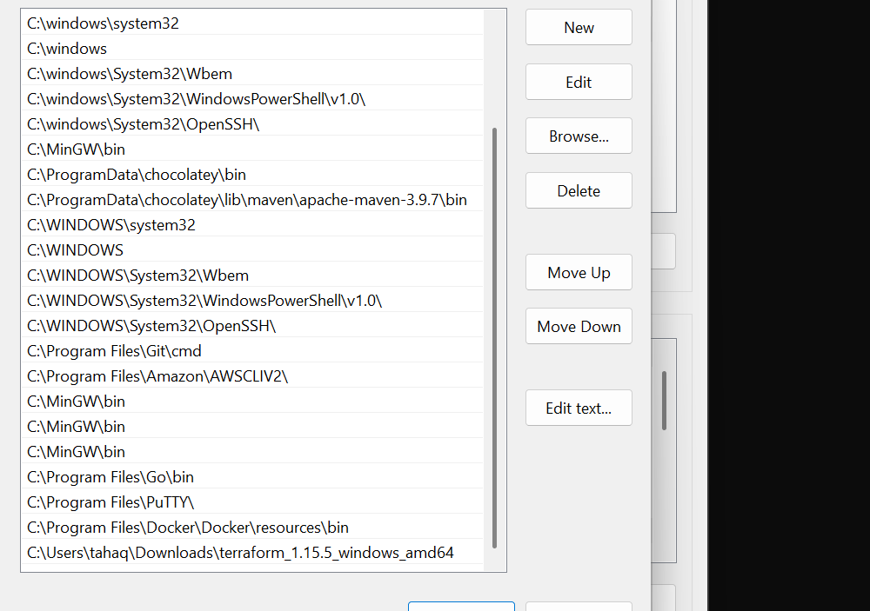
Add the terraform path in environment variables
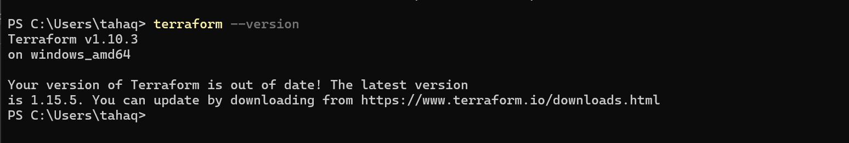
Terraform is now installed

2. Execute all the templates shown in video.
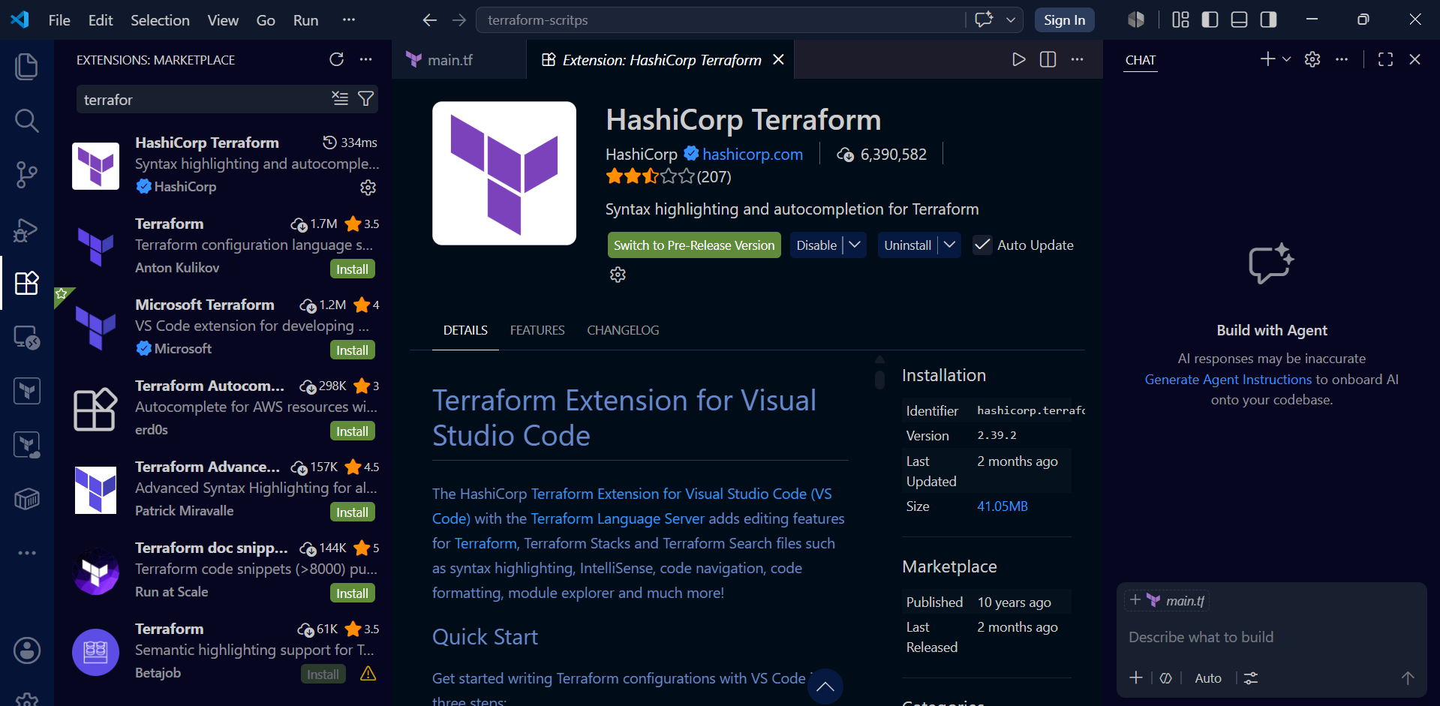
Install the terraform extension in visual studio code
Create file main.tf
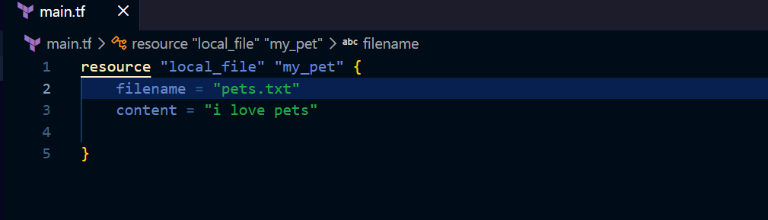

First do terraform init
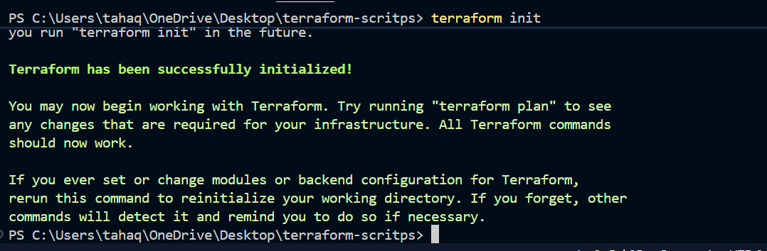
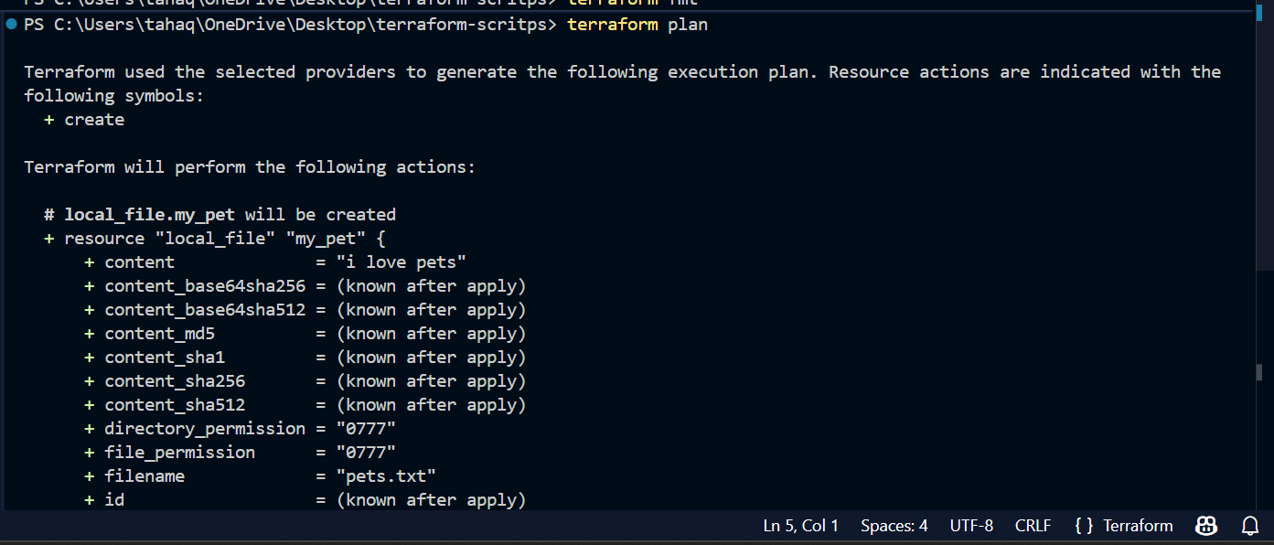
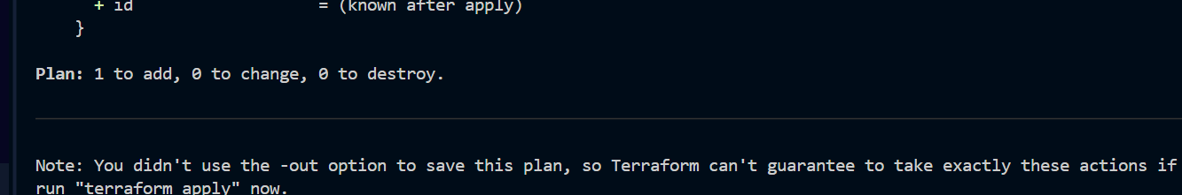
Terraform plan shows one thing to add

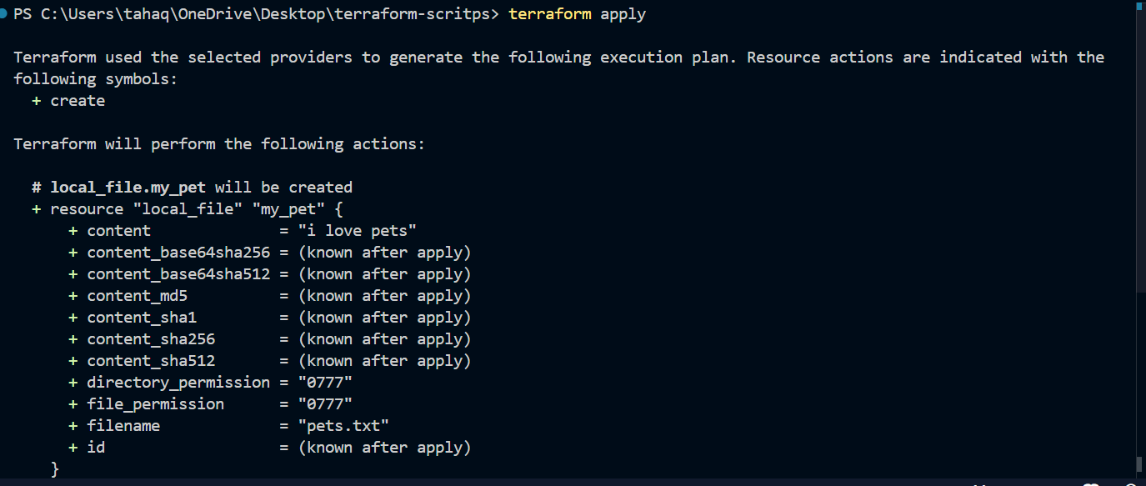

It has created the file
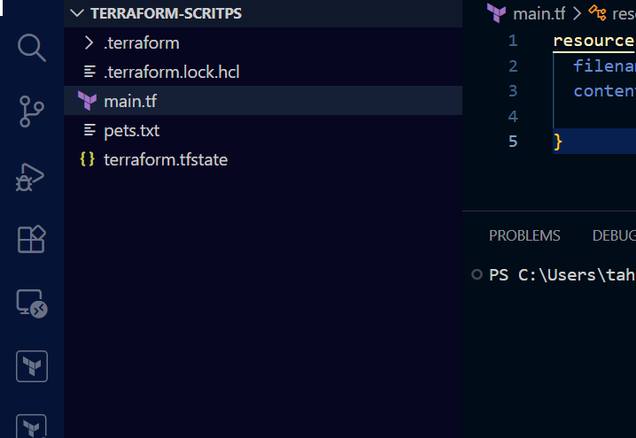
If we run terraform apply again without doing any changes in configuration file (main.tf)
Then nothing will be changed because of idempotent nature of terraform
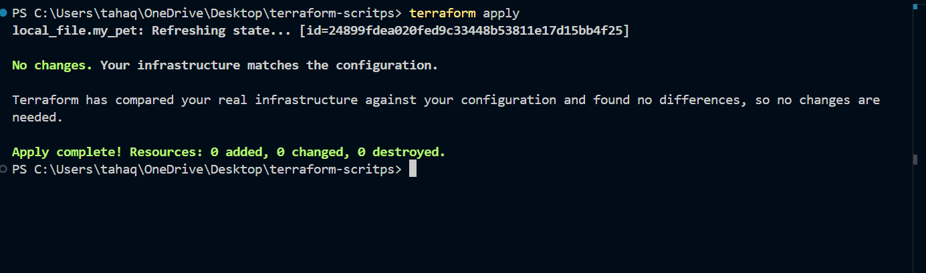

Here it has compared the files there was nothing to change so it did not change anything

3. Note down below points, Terraform Init Terraform Plan Terraform Apply Terraform Provider.
Terraform init
Purpose:
- Initializes the Terraform working directory.
- Downloads required provider plugins.
- Configures the backend for state storage.
- Downloads referenced modules.
When to Use:
- Before running any Terraform commands in a new project.
- After adding or changing providers/modules.
Terraform plan
Purpose:
- Creates an execution plan.
- Shows what resources will be created, modified, or destroyed.
- Does not make any actual changes.
When to Use:
- Before applying changes to review the impact.
Terraform apply
Purpose:
- Executes the changes defined in the Terraform configuration.
- Creates, updates, or deletes infrastructure resources.
- Updates the Terraform state file.
When to Use:
- After reviewing the execution plan.
Terraform provider : It is a complete package of api calls to communicate with our resources
a Acts as the bridge between Terraform and the target infrastructure platform.

4). Integrate a sample Terraform template in Jenkins.
On Jenkins server
Make sure that in Jenkins workspace folder main.tf file is preset and terraform is installed
Create a Jenkins pipeline job
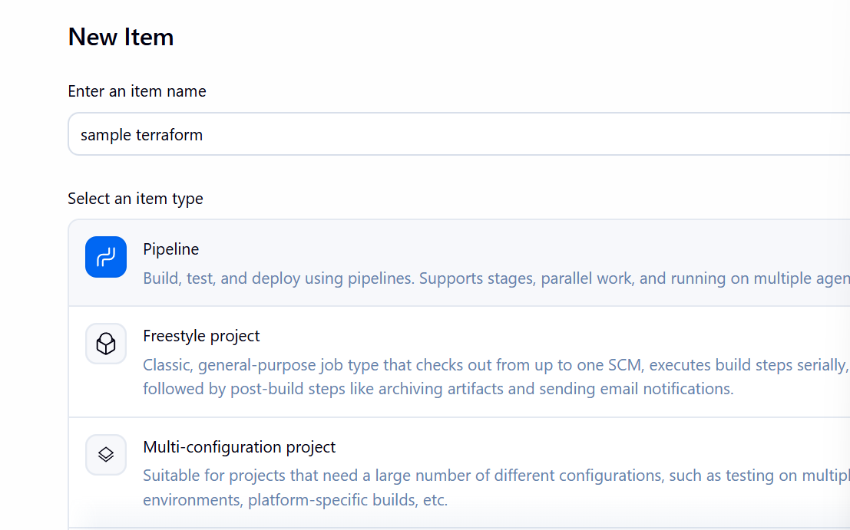

Write a declarative pipeline script ensure that terraform is installed in Jenkins server

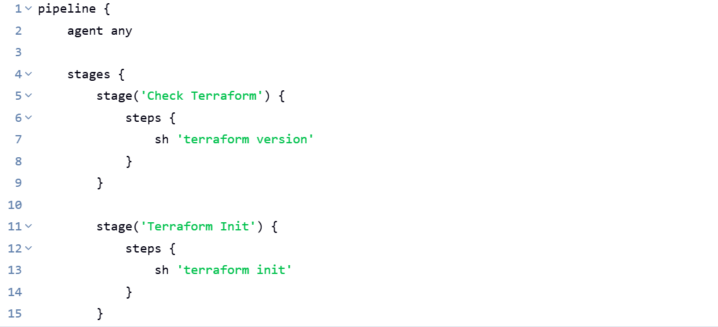
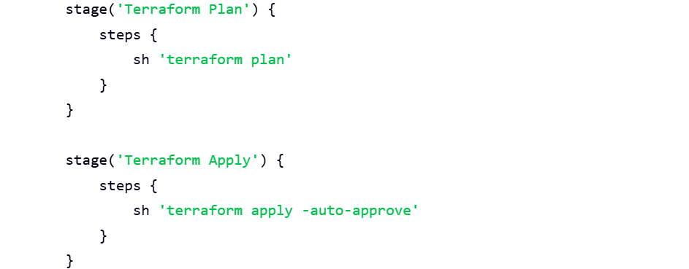

Run the pipeline now
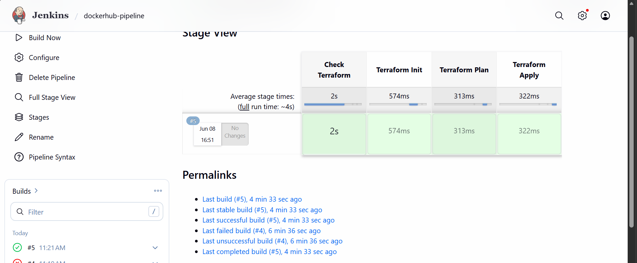

It executed successfully
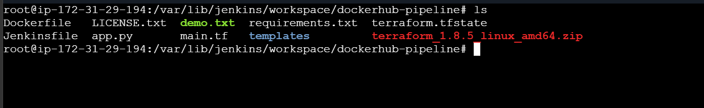
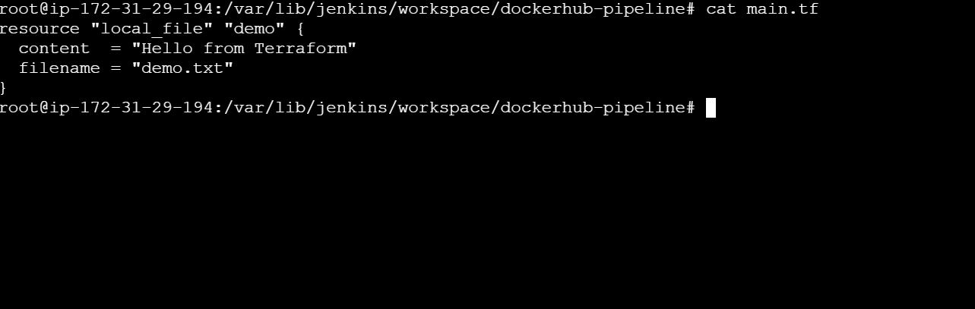
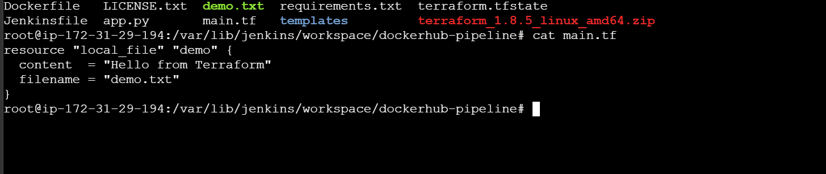
We have demo.txt and terraform state file which is been created by terraform

